**Using different work environments**

For this researching lab I’ve been playing with lots of code in different languages, text editors and operating systems. Some are better than others for certain types of code.

For me, this is a method of tinkering. In general, you could execute all kinds of programming languages in almost every text editor and operating system, but some are better for certain things then others.

In this lab I’ve mostly worked with three kinds of text editors. Visual Studio Code (this is my standard program), PyCharm (to work with python on bigger projects) and Jupyter Notebook (this is a special kind of editor also for Python). I also normally work with my Apple Macbook Pro, but during this research lab I’ve been using a Windows laptop and tried booting Ubuntu (Linux) from a bootable USB.

I really noticed in Python that due to dependencies and libraries not all projects that you find online (through Github for example) work on any operating system. It took me a while to figure out, but I really experienced the benefits of working with more than one operating system.

Some code worked better in a certain environment which I found out after trial and error. In the end it gave me a big insight on how to improve my programming without actually become better at programming itself. Normally I just used Visual Studio Code with my Macbook for practically anything, now I learned it can make my life so much easier if I do some projects in other text editors and/or other operating systems.

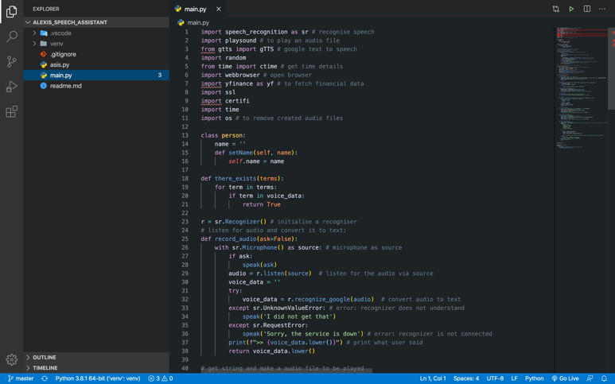

This method is easily combined with:

-

-

-

